|  |  |
| --- | --- |
| Assessment Title | Manage Albion Bay Council Library problem |

## Competency Details

|  |  |
| --- | --- |
| Unit code/s and title/s | ICTSAS527 Manage Client Problems |
| Qualification code/s and title/s | ICT50120 Diploma of Information Technology |
| Business unit/Work group | Business and Arts/IT Studies |

## Instructions

|  |  |
| --- | --- |
| Method/s of assessment | Questioning (Written) and Observation (Role Play) |
| Overview of assessment | This assessment will require you to analyse a client problem to determine the cause and develop a solution. You will then verify the support and resolution requirements to resolve the problem in writing with the client contact, develop and implement a solution. You will then communicate verbally with the client (Lecturer) to seek and act on feedback on the support provided. |
| Task/s to be assessed | This assessment will require you to complete the following tasks:   * Task 1 – Review client problem * Task 2 – Plan and implement support * Task 3 – Action feedback received |
| Time allowed | Refer to your schedule for submission dates |
| Location of assessment | Assessment can be completed anywhere with access to the resources required. (see Resources Required section below)  Task 2.3 role play needs to be completed using Microsoft Teams. |
| Decision making rules | To receive a satisfactory outcome for this assessment you must complete all parts correctly.  Word counts are provided as guidance only. |
| Assessment conditions | This assessment must be undertaken where conditions that are safe and replicate the workplace. Noise levels, production flow, interruptions and time variances must be typical of those experienced in the systems administration and support field of work.  Task 2.3 role play is an observable assessment, your Lecturer will assess you via observation.  All other written tasks are an unsupervised assessment and you may access any required resources.  This is not group work and must be completed as an individual. |
| Resources required | To complete this assessment, you will require the following:   * Access to Learn with Internet access * Learn resources * Office 2016 (365) * Windows 10 * Microsoft Teams * VMWare Workstation * Access to the iTop Service Management System * ASDS – ICTSAS527 Student files.zip * ICTSAS527 Assessment Scenario * ITWorks Work Instruction – Log ICT Incidents and Service Requests * ITWorks Work Instruction – Communication Standards * ITWorks Service Level Agreement * ICTSAS527_Foyer1 PC Virtual Machine (L:\ITStudies_NAS\Microsoft\VMs\SAS527) |
| Result notification and reassessment information | You will be provided feedback and the result for your assignment on TAFESA Learn. You will be and given the chance to resubmit with required corrections only once.  Refer to the TAFE SA assessment policy for more information <https://www.tafesa.edu.au/apply-enrol/before-starting/student-policies/assessment> |

Refer to the ICTSAS527 Assessment Scenario document prior to starting the following tasks.

**Task 1: Review client problem**

1. Find the PC details in the iTop service management system and complete the table below.

|  |  |
| --- | --- |
| **Foyer 1 PC Asset number:** | |
| Hardware | Model: ITW000001  RAM: 8GB  HDD: 60GB  Two partitions C and D |
| Operating system | Windows 10 pro |
| Applications | VLC Player  Office 365  Google  Adobe Acrobat |

1. What are the symptoms that Quinn is experiencing when trying to copy the video file to D drive and use the PC? Based on those symptoms what two areas would you focus on to determine the cause of the problem?

Quinn Gage has downloaded a video file called Library Cyber Security Month.mp4 from their SharePoint site to the Downloads directory on one of the foyer display PCs. He then tries to copy the file to the D drive where the videos are stored for play back, but then receives an error

Two areas of focus I would have is the available storage and file integrity.

1. Login to the Foyer1 PC to investigate. What is the cause of the error when trying to copy the video file to the D drive? Provide precise information in your response.

The issue with the video coping is that there is not enough storage space on the D drive to make the transfer, the remaining space on the D drive is around 282MB whereas the video has a size of 351MB meaning you need an extra 68.7MB of space on the drive.

1. What is the cause of the slow performance of the PC?

Provide precise information in your response.

When looking at the task manager and the resource utilization it is apparent that “Service host: Windows Update” another task that is running is called “test windows limits” which is maxing out the computer hardware at 99% utilization for both CPU and Memory.

1. Email the client contact to confirm support required to resolve the problem. Include your analysis of the problems and what you think is the cause for each. Ensure you construct the email as per the ITWorks Work Instruction – Communication Standards.

***Submit a screen capture of the email (do not send it) to the client contact to “Confirmation of support and resolution email – Task 1 submission” for assessment two. Once you have submitted you will receive an email from Learn with a response from the client contact.***

1. Using the ITWorks Work Instruction – Log ICT Incidents and Service Requests, log the problem as an incident in the iTop Service Management system and ensure that you include the following:
   1. Client details and accurate problem description
   2. Any time constraints for the problem
   3. Correct urgency and impact
   4. Your analysis in finding the causes of the problems

***Provide a screen capture of the ticket logged in iTop***

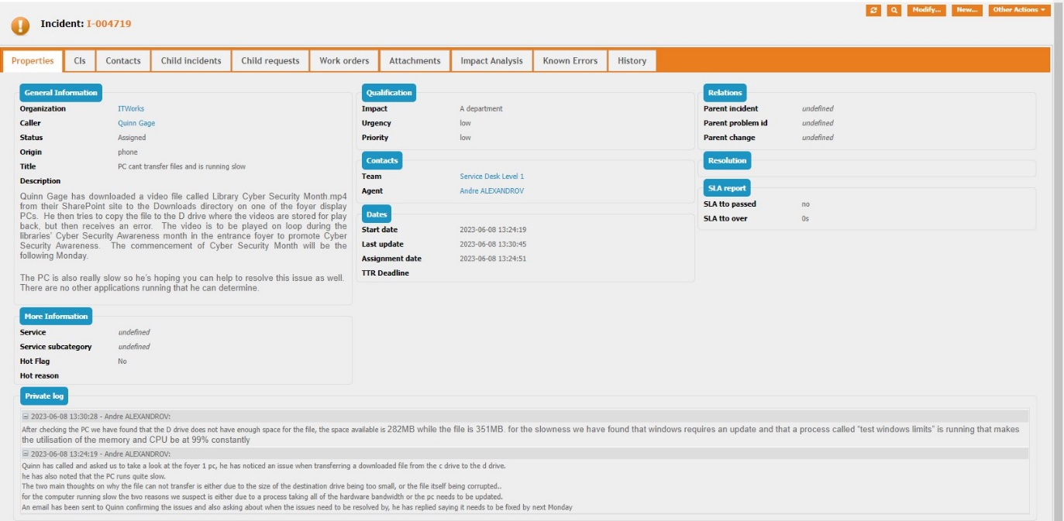s

**Task 2: Plan and implement solution**

1. Create a flow chart diagram showing the processes you will follow to resolve each of the problems with the library Foyer PC. Include your interaction with the client in this process.

The flow chart must contain the following steps at a minimum:

* + - Start and End
    - At least two of each of the following:
      * Decisions
      * Manual operations

** Save the flow charts as a JPG files and insert them here**

1. Implement the processes you have just created to resolve the problem for the Foyer 1 PC.
   1. Provide comprehensive documentation of your actions and their results in the private log of the ticket in iTop and:
   2. Test that you can now:

* copy the video file to the D drive
  + - play the video using the VLC Media Player
    - RAM utilisation at an acceptable level

***Provide screen captures of:***

* ***the updated private log of the ticket with your actions and their results***
* ***the Library Cyber Security Month.mp4 file on the D drive***
* ***the file being played using VLC Media Player***
* ***the Performance tab in Task Manager showing Memory usage***

**Screen captures must clearly show that these tests have been performed on the Foyer 1 PC virtual machine by including the top of the virtual machine window.**

1. Call the client contact (Lecturer), to verbally discuss:
   * + - how you resolved the problem with copying the video to the D drive
       - confirmation that the PC is now responsive and not performing slowly
       - obtain feedback on the service provided
       - respond to the feedback provided appropriately

Arrange a time to conduct the call with your Lecturer via email or during your scheduled class time.

***The call must be conducted via video conferencing using Microsoft Teams to simulate a workplace conversation.***

The role play should be approximately 5 mins.

Ensure that you:

* speak clearly and be succinct
* use listening and questioning techniques to conduct the call
* adhere to the communication guidelines for ITWorks

1. Update the private log of the ticket with all final actions and information after the meeting with Quinn and mark the ticket as resolved.

***Provide a screen capture of the updated and resolved ticket in iTop***

**Task 3: Action feedback received**

1. Review the ITWorks documentation you have been given for this assessment in relation to the feedback you were given from Quinn during the call.
2. Is the confirmation of problem resolution or service feedback mentioned anywhere in these documents? Provide any information you find relating to these two areas.
3. How would IT Support Officers know that they need to confirm problem resolution and seek feedback with the client?
4. If the Service Desk keeps the client feedback (including client details) for future improvements to processes and procedures:
   1. is it allowed to do so?
   2. can the Service Desk share the information with other IT Service Desks for case studies and
   3. what legislation does this practice relate to?
5. Write an email to your supervisor Jane Jones which includes:
   1. notification that the feedback process is not currently part of the procedure for logging and resolving tickets
   2. what documents you checked first looking for the procedure and what you found
   3. where you think it needs to be added in the ITWorks Work Instructions
   4. a draft procedure for seeking and responding to feedback from clients for her consideration

***Provide a screen capture of the email to Jane.***